**BUILD A PYTHON CODE , ASSUM EYOU GET A TEMPERATURE AND HUMIDITY VALUES GENERATED WITH RANDOM FUNCTION TO A VARIABLE AND WRITE A CONDITION TO CONTINUOUSLY DETECT ALARM IN CASE OF HIGH TEMPERATURE.**

PYTHON CODE: 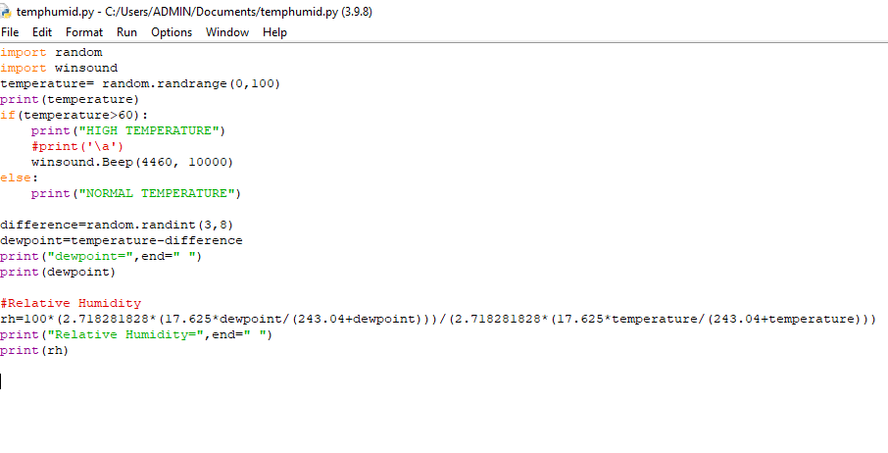

OUTPUT:

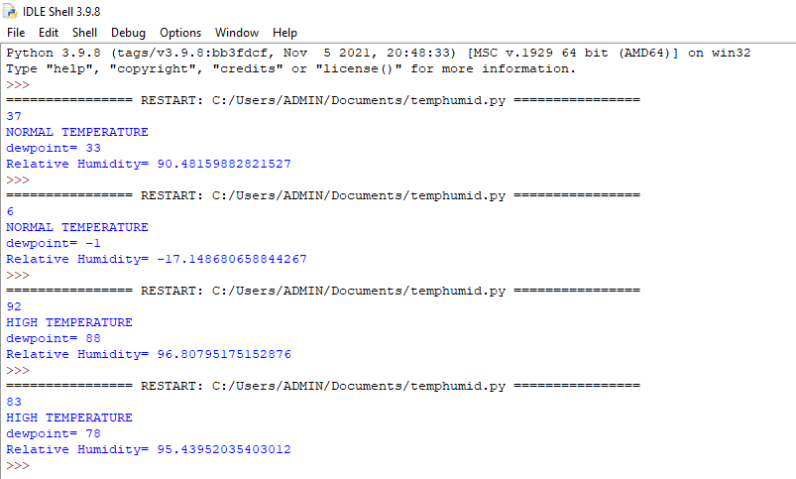

**IN ANOTHER WAY:**

CODE:

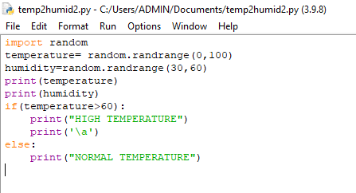

OUTPUT:

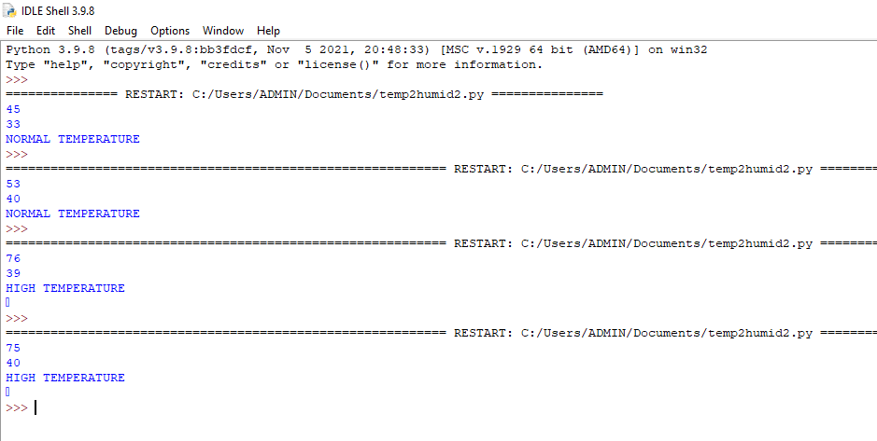

**LINK FOR THE VIDEO**

**https://drive.google.com/file/d/1elVVG7zVG5dWDWgX9ePDr-9G1h0d7CQK/view?usp=sharing**